VCS Commissioning

Needs Analysis

Contents
Executive summary 2
Summary of need for community support illustrated by Reading Borough Council’s Poverty Needs Analysis 2020 3
Summary of need for community support illustrated by the Joint Strategic Needs Assessment 5
Key findings from Public Health England’s ‘Wider Impacts of COVID-19’ tool 9
Key findings from Public Health England’s COVID-19 Mental Health and Wellbeing Surveillance tool 13
Public feedback on VCS services gathered during the Berkshire West Health & Wellbeing Strategy Consultation 15

Executive summary

Since 2016, Reading Borough Council (RBC) has commissioned a range of community support services from voluntary sector organisations through its Narrowing the Gap (NTG) commissioning frameworks. The services have covered three broad areas:
- tackling poverty
- supporting thriving communities
- promoting (adult) wellbeing

These are funded through combined Adult Social Care, Public Health and Corporate Council budgets, including Housing Revenue Account. RBC commissions services from the third sector in other areas, e.g. homelessness prevention, cultural provision and transport – but using other processes.

Previous NTG commissioning has been underpinned by needs analyses drawn from:
- the Joint Strategic Needs Assessment;
- the Poverty Needs Analysis;
- a review of activity under previous commissioning arrangements; and
- a period of engagement with the local third sector
prior to the publication of each framework.

This Needs Analysis updates and collates information about community support needs – focusing on adult health and wellbeing, poverty and inclusion - to support the development of commissioning plans by RBC in this area from 2022, as well as a broader review of the Council’s partnership working with local third sector organisations. It draws on the following sources:
- Reading Borough Council’s Poverty Needs Analysis 2020
- Reading Joint Strategic Needs Assessment
- PHE Wider Impacts of COVID-19 (WICH) tool
- PHE Mental Health Surveillance Tool
- Public feedback gathered through a consultation on the 2021-30 Berkshire West Health and Wellbeing Strategy
- Evidence of demand from reviews of RBC commissioned services delivered by VCS providers within the NTGII framework.

The introduction of the NTG frameworks largely replaced the annual grants round which RBC had run for many years prior to 2016. However, in 2020, the Council re-introduced a general grant’s offer. This was focused on COVID-19 responses and adaptations in the first year and operated alongside the allocation of some specific COVID-related funding to VCS partners. NTGII contracts also continued during the pandemic, albeit with some re-focusing as appropriate in order to comply with social distancing rules and to support the COVID response more generally.

In 2021, the Council is running another grants round, informed by the work of the Social Inclusion Group to identify priority areas of community support as part of Reading’s COVID recovery plans.

Many of RBC’s current funding arrangements (contracts and grant agreements) with voluntary sector partners will come to an end in the early months of 2022.

Findings

There is clearly an ongoing need to address adult health and wellbeing, poverty and inclusion issues within Reading. Community need in all three areas either has demonstrably increased already or is set to do so as we go into 2022. Against a backdrop of activity well in excess of target levels across almost all the NTG services currently commissioned by RBC, there is a need to review prioritisation within these three areas in order to determine how best to allocate limited resource.

Most NTG providers which have been delivering over target have used additional income from grants (usually specific to COVID and some issued by RBC) and/or have drawn on reserves to fund this.

COVID-19 has not only led to increased community need, but has led to support needs emerging within new cohorts, e.g. those employed in what were considered to be relatively stable sectors prior to the pandemic, healthy younger adults faced with periods of social isolation, and many struggling to adapt to lockdown and/or re-adjust as social distancing rules as relaxed - with mental health challenges as a result. What is also clearer now than when the previous NTG Needs Analyses were completed is the extent to which inequalities persist and indeed are increasing in some areas. Many of the challenges of COVID have hit residents from a Black or Minority Ethnic background harder. This includes greater risk from the virus because of underlying health conditions, greater exposure linked to occupation and/or living conditions, and greater risk to income linked to disproportionate levels employed on zero hours contracts. This indicates a need to focus limited resource on our most excluded or at-risk residents if the Council’s funding for community support is to have the biggest impact.

RBC now has a Social Inclusion Group focusing on poverty and inclusion, in particular, although recognising the links with health inequalities too. Child-poverty and in-work poverty have been identified as areas of focus. Digital inclusion has been recognised as underpinning a growing divide, with so many services having moved online during the pandemic, and some likely to remain so exclusively.

Lockdowns, restrictions on movement or social contact, fear of contracting COVID and the experience of COVID individually or within families have all had an adverse impact across the population as a whole in terms of physical and mental health. Again, the challenges have not been experienced equally. Those advised to shield or classed as more vulnerable to COVID are likely to face greater challenges in re-engaging with services or communities. Disruptions and anxieties linked to living through COVID have been felt more keenly by people from Black or Minority Ethnic communities, those with pre-existing physical or mental health problems, unpaid carers, parents, and those on lower incomes. The significance of loneliness as a risk factor for health has been highlighted during the pandemic. Our understanding of which groups of residents are at greater risk of loneliness or social isolation has shifted, however. The need for support in this area for younger adults has grown, and the link between loneliness risk and low income has become a more significant consideration given the financial impacts of COVID at an individual level.

Summary of need for community support illustrated by Reading Borough Council’s Poverty Needs Analysis 2020

General deprivation

Reading is the fourth largest urban area in the South East, a UK top-ten retail destination with a thriving night-time economy, and home to the largest concentration of ICT corporations in the UK. However, there is a clear mismatch between Reading’s outstanding economic success and the level of benefits to local people. This is illustrated by a comparison of the earnings of the workforce with those of the resident population – gross annual earnings for residents in 2019 was £32,852, compared with £34,205 for Reading workers.

Equally graphic is the scale of the gap between Reading’s most and least prosperous neighbourhoods. Reading has some of the most affluent and the most deprived neighbourhoods in the whole of the Thames Valley.

5 LSOAs (Lower Super Output Areas) are within the most deprived 10% nationally, according to the Index of Multiple Deprivation 2019, up from 2 in IMD 2015. This suggests that the disparity between deprived and well-off areas has increased. And according to the Centre for Cities report, Reading is the 3rd least equal city (after Oxford and Cambridge and joint with London and Brighton).

The Council’s Social Inclusion Group has identified three key areas of focus directly linked to data analysis of poverty in Reading:

- Child poverty

Child poverty has long-lasting effects e.g in terms of educational attainment and infant mortality. Although child poverty in the UK reduced dramatically in recent years, figures have more or less flat-lined over the last decade. There has been a large rise in the proportion of poor children who are in families where someone is in work. Lone-parent families and families with three or more children are particularly at risk.

On a Reading-wide level, Reading is below the national level with almost 1 in 7 children, or 15%, in relative poverty, with this level stable since 2016/17. However, this rate rises to 23% in Whitley, 21% in Church and 20% in Norcot and Southcote.

- In-work poverty

Although prior to the COVID-19 pandemic, unemployment in Reading had been falling for a number of years, the high employment rate has traditionally masked a far more serious and widespread issue of low income amongst some of the employed. Being in work is no longer a guaranteed route out of poverty. There are now more people on temporary contracts and in self-employment, for whom incomes have been falling.

In Reading, there is a disparity between residents and workers in terms of skills. 4 LSOAs are in the most deprived 5% nationally in terms of ‘education, skills & training’, according to Index of Multiple Deprivation 2019, up from 3 LSOAs in IMD 2015. % 19 year olds gaining level 2 qualifications (76%) and level 3 qualifications (59%) has decreased, and the level 2 percentage is below national average.

- Digital exclusion

Digital exclusion means a lack of internet access and/or low levels of digital literacy and skills. This can result in people being excluded from a whole range of online services, from banking to buying groceries to accessing job searches. They may be forced to pay more than others for goods and services and may suffer from isolation and loneliness. The pandemic has now significantly increased the need to be able to do things online, and this is likely to continue.

Those aged 70+, those living alone, those with a condition that limits or impairs their use of communications services, and those who are financially vulnerable are more likely to be digitally excluded.

Although Reading is relatively digitally included as a whole, there are many areas of the community which are excluded. ONS have designated 2 LSOAs within the most digitally excluded 10% in the country.

Research carried out by the Whitley Researchers in collaboration with the University of Reading in 2020 indicates that the most important barrier is lack of knowhow, followed by lack of equipment and good connectivity, often due to affordability. Motivation is also an important factor, with a third of those interviewed resisting to use the internet, primarily due to lack of confidence.

The Social Inclusion Group has identified a fourth focus area – mental health. Current understanding of Reading need in this area is described more fully below.

Summary of need for community support illustrated by the Joint Strategic Needs Assessment

The Joint Strategic Needs Assessment (JSNA) provides key information to underpin the planning of health, care and community services so as to empower people to live longer, healthier and happier lives, and to reduce health inequalities.

The overall health status of the local population is summarised in Reading’s JSNA from Census data. In 2011, Reading as a whole had more residents describing their health as ‘good or ‘very good’ than the average rate across the South East or for England as whole. However, 5,846 Reading residents described their health as ‘bad’ or ‘very bad’. 8,815 residents described their day to day activities as being ‘limited a lot’ by a health problem, with a further 11,295 describing their day to day activities similarly being ‘limited a little’. This starts to provide an estimation of the number of people who may need community support to maintain or improve their wellbeing.

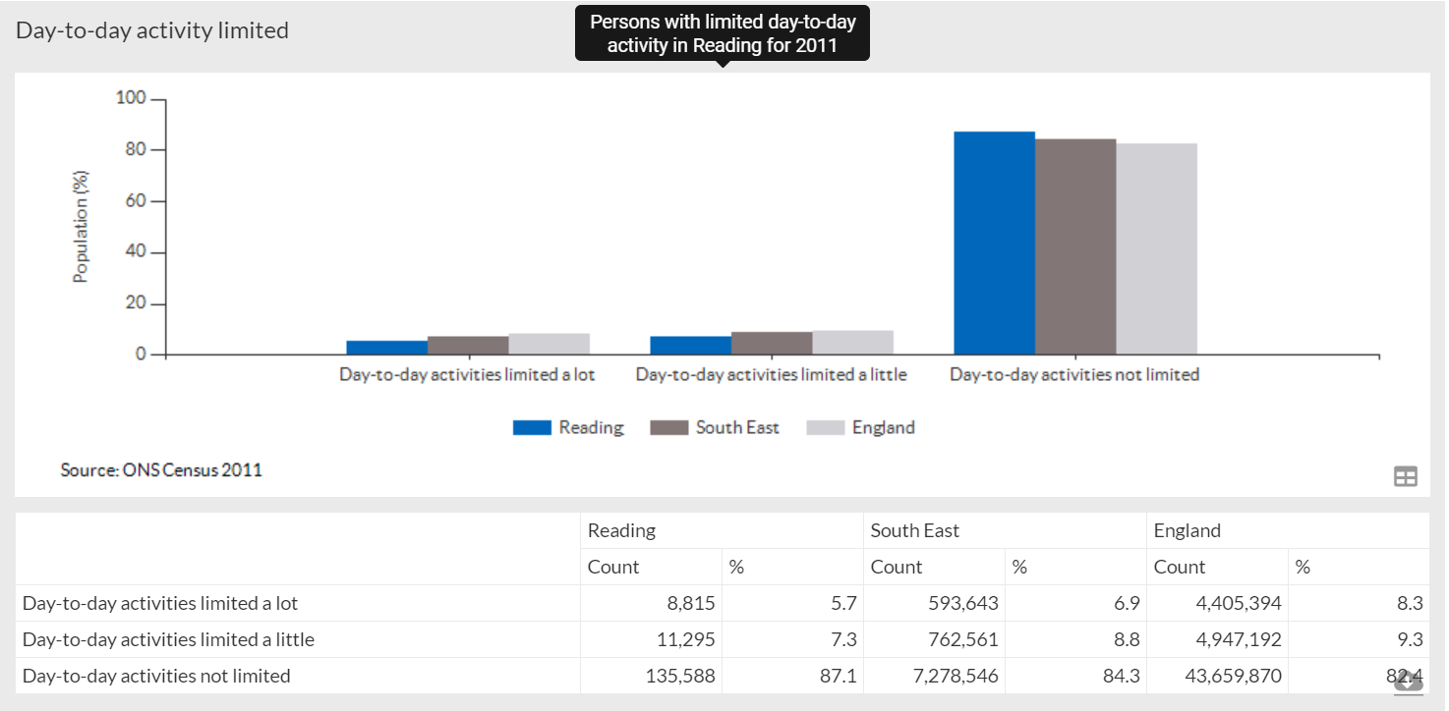

A more recent although less comprehensive source is the Household Survey reported by the Office for National Statistics. This asks people to rate their wellbeing against four measures – overall life satisfaction, happiness, anxiety and feeling that daily activities are worthwhile. In 2016-17, Reading residents were more likely to report low happiness and/or high anxiety.

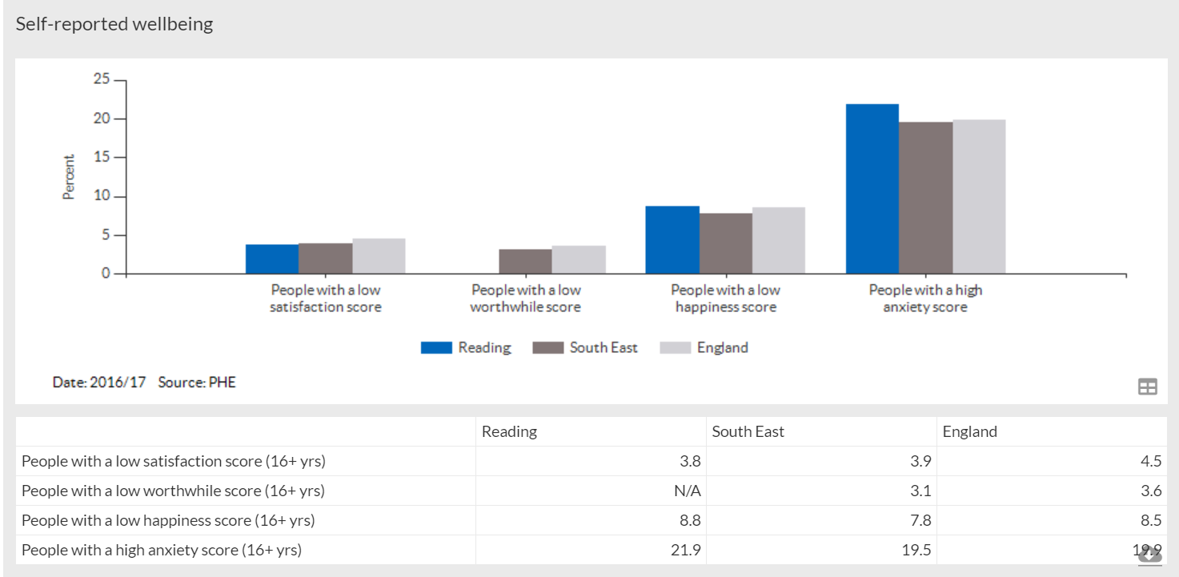

Emergency hospital admission rates for self-harm were significantly higher in Reading than in the South East or England according to published data in 2016-17. This data gives an indication of mental health support need in the community, as well as identifying areas of increased suicide risk.

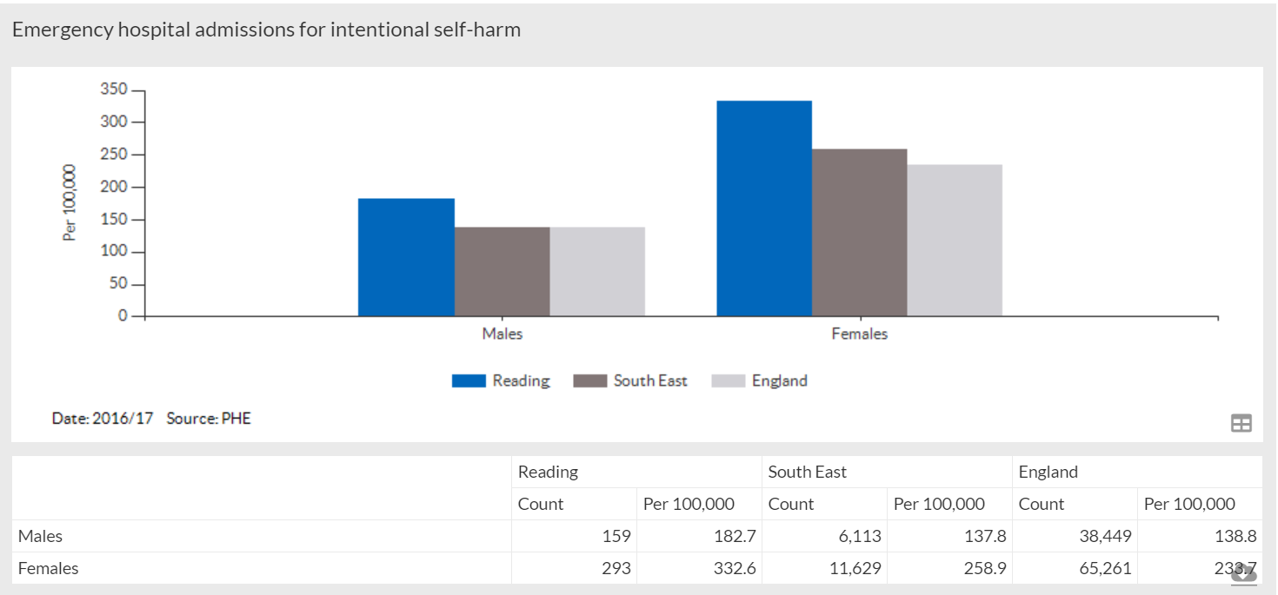

Hospital admission rates for alcohol-related conditions were lower in Reading in 2016-17 than for England or for the South East as a whole, although there were still a total of 852 incidents recorded that year. It should be noted that for both alcohol related harm and self-harm, the hospital admissions data only tells part of the story as there will be additional incidents which don’t lead to a hospital admission but still contribute to deteriorating health.

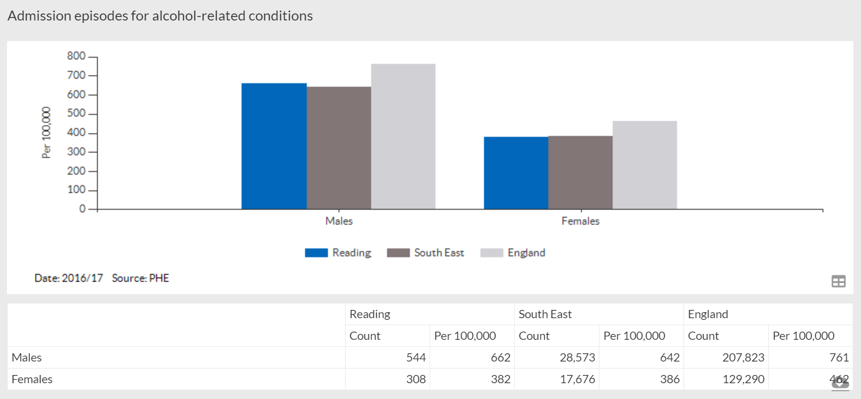

Latest published data on winter deaths (covering the period 2014-17) showed that the increase in death rates for those aged 85+ over the winter months was on an upward trajectory in Reading after falling previously. This is a measure which gives an indication of overall health levels in the older population, but also how well people are able to cope with a drop in temperature. This links to levels of poverty and deprivation.

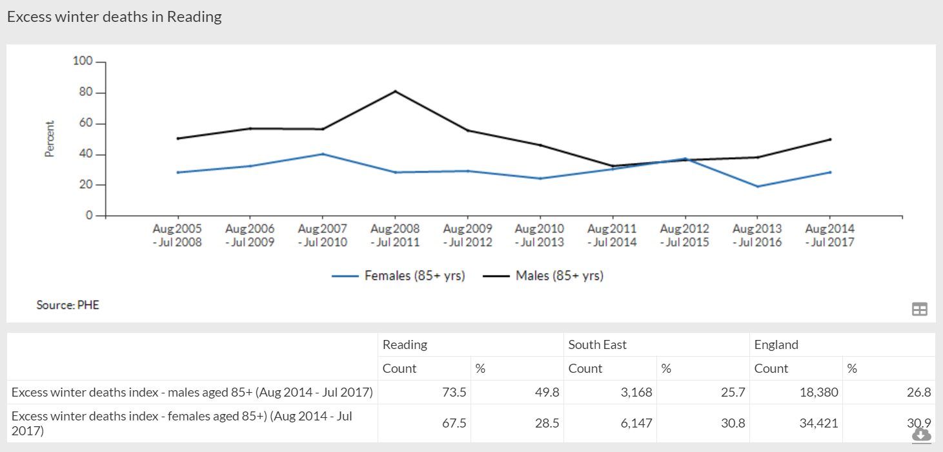

Another important measure of health in the older population is the rate of hip fractures in those aged 65+. Only one in three people who experience a hip fracture return to their former levels of independence. Another one in three will leave their own home for long-term care. In 2017-17 the rate for males in Reading was slightly above the England and South East averages, with the female rate lower than either of these comparators.
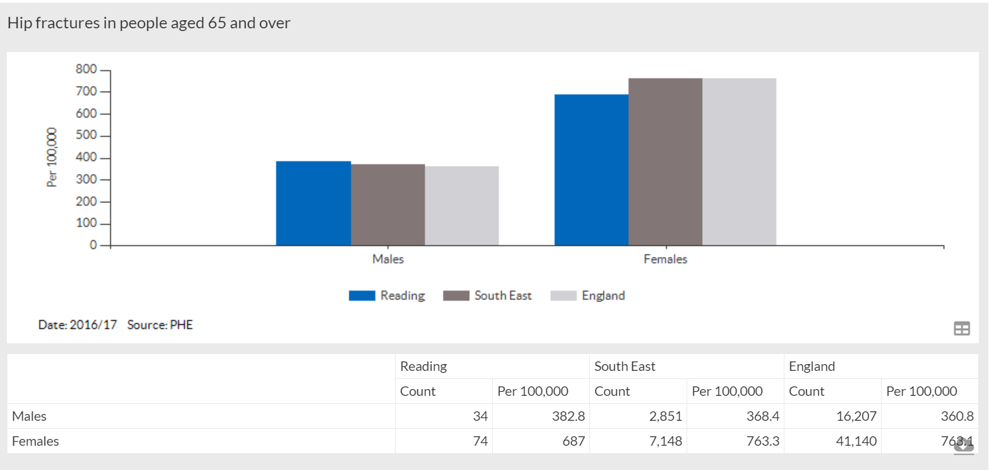

Poor mental and physical health are often associated with loneliness or low levels of social contact. Support to reduce the risk of social isolation has been a very significant area of the Council’s VCS commissioning in the past, with services focused on various identified high-risk groups. Until recently, national data has only been collected for users of Adult Social Care and for carers known to Adult Social Care (although broader data is now becoming available – see below). In 2017-18, 41.4% of Adult Social Care users surveyed in Reading reported they had as much contact as they would like, which was lower than the England or South East average. Just 36.2% of carers in Reading reported they had as much social contact as they would like, although this was higher than the England or South East averages.

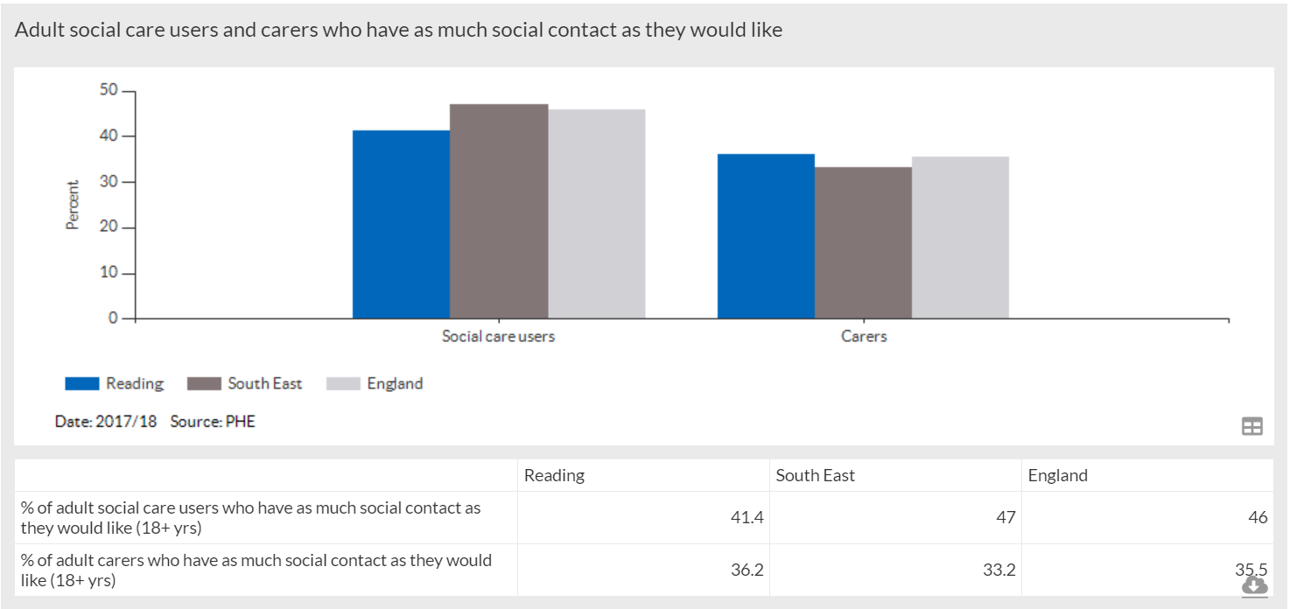

The Reading 2018 ‘Loneliness and Social Isolation in Reading’ Needs Analysis sets out how becoming lonely or socially isolated is a complex process affected by a range of interrelated factors, but concludes that individuals may be at greater risk if they:
- Are single (have no current spouse or life partner);
- Have recently experienced a significant change to their life;
- Are impeded by practical barriers (e.g. a health problem, transport, lack of time or energy); or
- Lack economic or social resources.

Whilst validating the all-age approach taken by the Reading Loneliness and Social Isolation Steering Group, this Needs Analysis found that older people or older working age people were more likely to be exposed to the identified risk factors. The Analysis went on to identify evidence-based solutions.

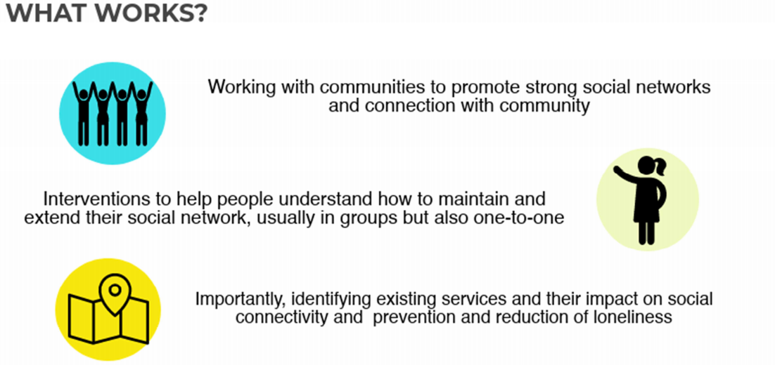

Further research was commissioned from the University of Reading to help develop an in-depth understanding of the dynamics of loneliness and social isolation in Reading and to identify best practices which may prevent and tackle it. The ‘Tackling Loneliness and Social Isolation in Reading’ report published in 2019 included a series of recommendations:
- Raising awareness about loneliness and social isolation (LSI) and its links to health and wellbeing among statutory and voluntary and community sector service providers, employers, schools, members of the public
- Greater provision of specialist support services for groups at risk of LSI, encompassing tailored one-to-one support, as well as group activities, with increased opening hours, particularly at weekends
- Fostering more collaborative working ‘joined-up’ thinking and signposting between organisations, Reading Borough Council and primary healthcare providers
- Increasing the affordability and social accessibility of transport, including through concessionary fares, building people’s confidence, supporting and raising awareness about alternative transport services for people with complex needs and carers, such as ReadiBus and neighbourhood volunteer transport initiatives
- Developing and supporting peer support initiatives and befriending and volunteering schemes
- Fostering good neighbourliness, supportive faith communities and community development
- Providing more accessible information, communication and promotion of activities and services in appropriate formats.

Key findings from Public Health England’s ‘Wider Impacts of COVID-19’ tool

During the COVID-19 pandemic, Public Health England developed the ‘Wider Impacts of COVID-19’ – or WICH – tool to provide close-to-real-time updates on factors affecting health. It became apparent early on that COVID-19 was having a broad impact on health and health inequalities in England, going well beyond mortality rates, and the WICH tool was designed to support interventions to mitigate against risks to population health.

WICH analysis considers the different phases of restrictions imposed to help reduce the spread of COVID-19. The first national lockdown in England began on 23 March 2020, and easing began from 10 May, progressing into the summer so that from early July a wide range of facilities were permitted to open provided social distancing measures were in place. From October 2020, local restrictions were imposed based on a tier system. A second national lockdown ran from November until 2 December when the local tier system was reinstated. Reading was included in Tier 4 (highest level) restrictions for London, East and the South East of England from 20 December. A third national lockdown came into effect on 6 January 2021. Easing has since progressed in stages since 8 March 2021.
Alongside local activity data from commissioned providers (see below), the WICH data highlights some of the impacts of COVID-related restrictions on movement. These need to be considered alongside validated - but earlier - data on community need (see above) as we plan for commissioning in a post pandemic era.

Headline findings from the national WICH analysis are as follows.

Employment
Across England, redundancies more than tripled over the period September to November 2020 compared to March to May 2020. Unemployment benefit claims more than doubled between March 2020 and May 2020 and have remained at a similar level since then up to April 2021.
Proportion of resident population aged 16-64 claiming unemployment benefits

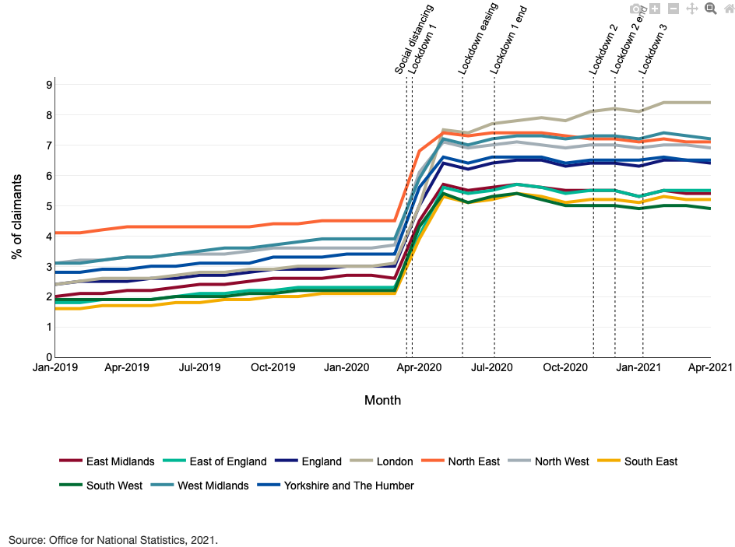
Although the South East region continues to have one of the lowest unemployment rates, the increase from the early months of 2020 remains significant. Moreover, the increase in unemployment seen so far may not yet reflect the full impact of the pandemic on economic activity. Many employees have been furloughed for extended periods, but ultimately may not be able to return to their pre-pandemic jobs.

Health status and access to healthcare

YouGov surveys show that the highest rate of self-reported new or worsening health conditions in 2020 corresponded with the first national lockdown. For most age groups, the rate dropped during the easing of restrictions and then into the second and third national lockdowns. However, for people aged 18-34, the highest rate occurred during the easing period.

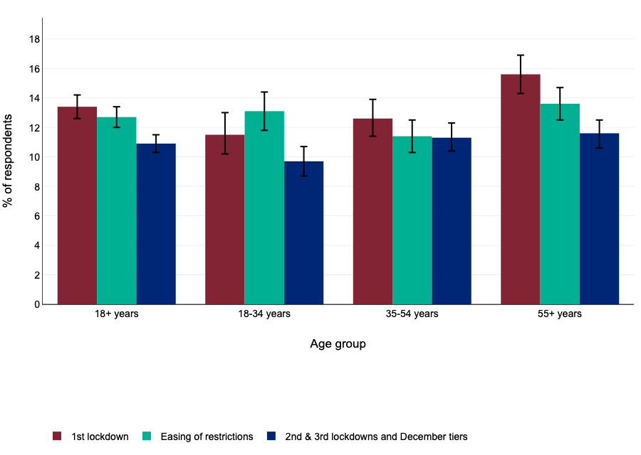

Survey data collected from July 2020 to January 2021 showed that of those people reporting that they had a worsening health condition in the preceding 7 days, around half reported that they had not sought advice for their condition. At each of these three periods compared, the most common reason people gave for not seeking advice for a worsening health condition was wanting to avoid pressure on the NHS, followed by concerns about catching COVID and then concerns about leaving the house.

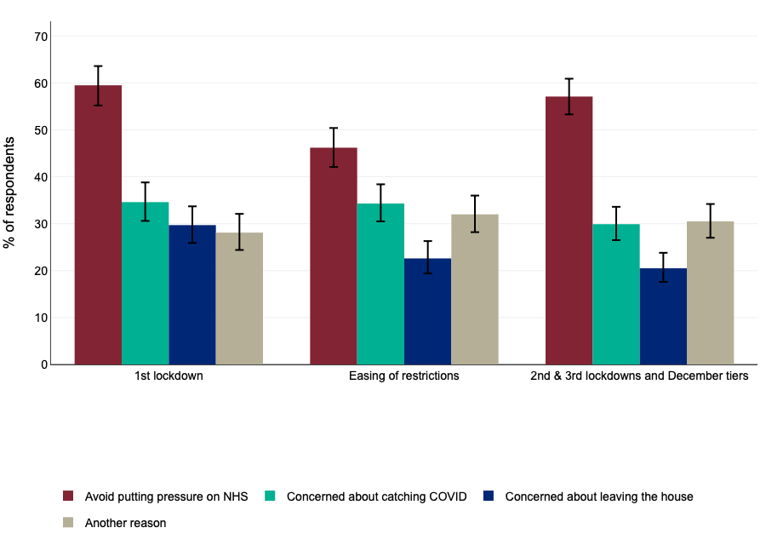

Elective and emergency hospital admissions from April to December 2020 in England were lower than the monthly averages for the equivalent months in 2018 and 2019 combined. This pattern was observed in men and women, and across all age groups, ethnic groups and deprivation deciles. In children and young people, rates of hospital admissions from April to December 2020 were generally below the average rates in 2018 and 2019 for equivalent months. Both A&E and outpatient attendances were lower in 2020 for every age group.
All of this suggests that true rates of ill-health in the community may be higher than official statistics suggest, with more people receiving later diagnoses which has implications for the complexity of need.

Physical activity levels
One of the particular challenges of lockdown and social distancing rules was maintaining physical activity. This can be a highly effective protective health behaviour and leaving the home to exercise was always allowed to some extent, alongside encouragement to exercise indoors as an alternative. However, following this advice wasn’t always practical for everyone, with variations in the amount of indoors space people have, the accessibility of outdoors areas local to home, and challenges linked to people’s personal circumstances, e.g. parents who were home schooling, or those with long term health conditions which limit the forms of exercise which are suitable. People who were given the strictest advice on avoiding social contact – the Clinically Extremely Vulnerable – often found it hardest to leave the home whilst following other advice, alongside other vulnerable groups, such as those aged over 70.
Across all age groups, self-reports of physical activity levels (by parents on behalf of children) are that this increased during 2020 for one third of the population but decreased for another third. There are also variations in levels linked to other demographic factors, e.g. social class.
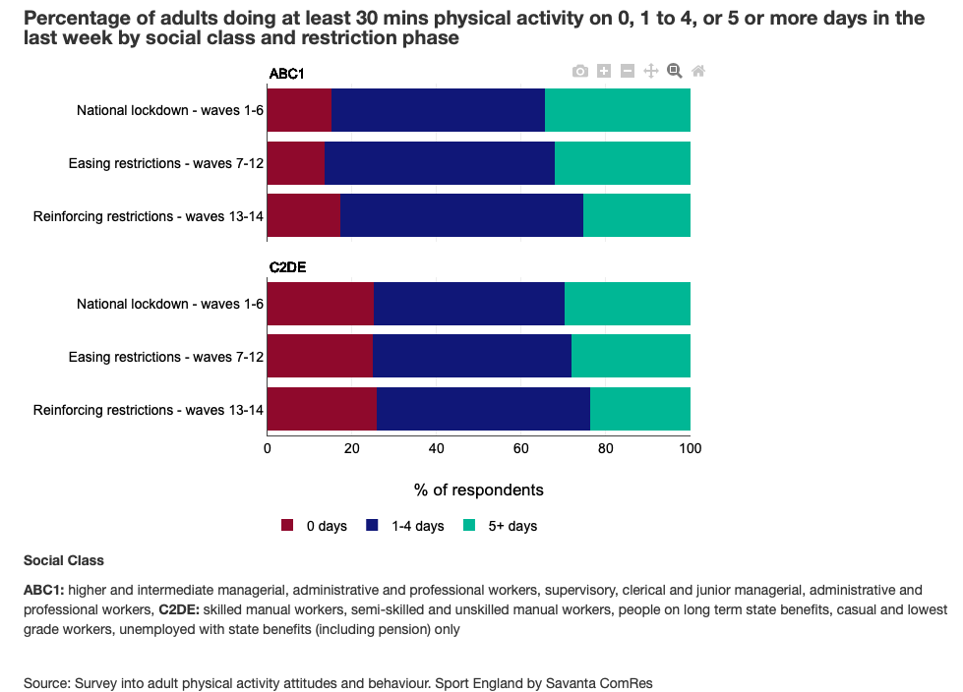

After prolonged periods of physical inactivity, often linked to not leaving the house, returning to pre-pandemic activity levels may take quite a bit more for some individuals than simply being allowed to do so. There is widespread anecdotal feedback that residents who have remained at home for most of 2020 and into 2021 have lost both mobility and confidence. This makes it difficult for them to re-connect with their community or to access various services.

Key findings from Public Health England’s COVID-19 Mental Health and Wellbeing Surveillance tool

Alongside producing the WICH tool, Public Health England also developed a specific tool to offer close to real time surveillance of population mental health and wellbeing during the pandemic.
Collated data across a range of sources shows that self-reported mental health and wellbeing worsened during the first national lockdown, with psychological distress, anxiety and depressive symptoms appearing to peak in April 2020. Things then improved over late summer and early autumn but appeared to dip again over late autumn through into the early part of 2021.
Within these population level summaries, however, there were variations in the experiences of different sections of the community.
- Younger adults (aged 18 to 34) and women were more likely to report worse mental health and wellbeing during the first national lockdown than older adults and men.
- Older adults who were recommended to shield (i.e. initially categorised as Clinically Extremely Vulnerable) were more likely to report higher levels of depression, anxiety and loneliness in the early summer of 2020 than people of a similar age who were not recommended to shield.
- Older adults with multi-morbidities reported higher levels of depression and loneliness than older adults without multi-morbidities.
- Women were more likely than men to have made larger adjustments to their usual routines during the pandemic in order to manage housework and childcare, and these adjustments were associated with increased distress.
- Adults living with children were more likely to report a deterioration in their mental health than adults living without children, with lone mothers appearing to have been particularly vulnerable.
- Some studies have found that men from Black, Asian and Minority Ethnicity groups reported a larger deterioration in mental health than White British men, whilst the deterioration reported by women from Minority Ethnic groups was similar to that reported among White British women.
- Adults with pre-existing mental health conditions have reported higher levels of anxiety, depression and loneliness than adults without pre-existing mental health conditions.
- Several studies found that adults with long term physical health conditions reported worse levels of depressive symptoms than adults without long term physical health conditions.
- Unpaid/informal carers were more likely than non-carers to report depressive symptoms.
- A greater proportion of adults with low household income or in lower socioeconomic groups reported symptoms of anxiety and depression than adults with higher household income or socioeconomic position. This needs to be considered alongside reports that the various income protection schemes offered by central government are less likely to have benefited people from immigrant populations or women.
Loneliness
The Mental Health and Wellbeing Surveillance Tool includes data on people’s reports of loneliness. The relationship between loneliness and mental ill-health is a complex one, where each can trigger the other although the two may be experienced independently. It can also be difficult sometimes to distinguish between the two at the level of individual need so as to offer the most effective support.
Loneliness data collated for the Mental Health and Wellbeing Surveillance Tool is sometimes inconsistent but results from the Community Life Survey suggests a trend of increasing loneliness since the first national lockdown.
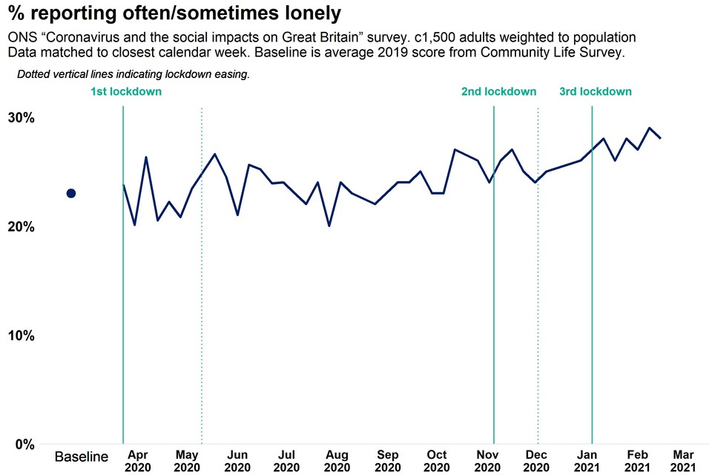
It appears that those who were most lonely prior to lockdown were most likely to report an increase afterwards. Young adults, women, people with lower levels of educational attainment, people on a low income, people who are economically inactive, people with an existing mental health condition, people living alone, and urban residents were also all more likely to report being lonely during the pandemic. Older people with multiple health conditions, or who were shielding or self-isolating, were found to be particularly affected by loneliness during the pandemic.
Taken together, these studies into population groups identify a number of risks to mental wellbeing linked to COVID-19: mortality concerns, fears about the virus, grief for the loss of normality, restricted access to health and other services, low/insecure income, employment as a key worker, parenting or caring responsibilities, and loneliness / social isolation. However, they also identify a number of protective factors: slower pace of life, maintaining a routine, socialising and use of past coping skills to manage adjustments. Understanding these factors helps to predict what support for mental wellbeing is likely to be needed as we continue to progress out of COVID related restrictions.

Public feedback on VCS services gathered during the Berkshire West Health & Wellbeing Strategy Consultation

From December 2020 through February 2021, residents of Reading, Wokingham and West Berkshire were invited to participate in a public engagement exercise to identify the priorities for a new Berkshire West Health and Wellbeing Strategy. This generated 1,200 Reading responses via an online survey in addition to attendances at virtual focus groups.

Following this engagement exercise, the priorities for the Berkshire West Health and Wellbeing Strategy 2021-2030 were identified as:
- Reduce the differences in health between different groups of people
- Support individuals at high risk of bad health outcomes to live healthy lives
- Help families and children in early years
- Promote good mental health and wellbeing for all children and young people
- Promote good mental health and wellbeing for all adults
Although these top five are not ranked, ‘reduce the difference in health between different groups of people’ was consistently identified as the most important issue, and is now expected to underpin delivery plans across all of the priority areas.

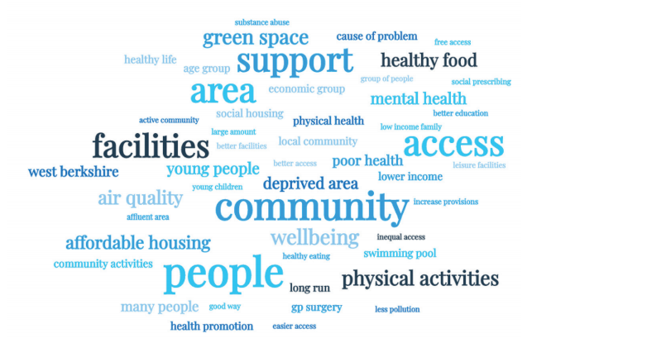

The Health and Wellbeing Strategy consultation did not expressly invite feedback on voluntary and community sector services or what should be commissioned from the third sector in future.
However, as the visualisation of ‘health inequalities’ comments above demonstrates, comments regularly considered ‘community’ alongside other health and wellbeing concepts. Respondents went on to highlight the value of VCS organisations as connectors between communities and statutory services – both to ensure local intelligence and perspective inform planning, and to ensure that information and services reach all sections of the community.

This consultation took place during the pandemic and reflected people’s experiences of dealing with COVID-19 in Reading. There were several references to the challenges some communities faced in receiving information and support from statutory services, leading people to conclude there was a need for better understanding of the diversity of Reading residents and better targeting of support. Specifically, people felt there was a need for more culturally sensitive services to help break down stigma or mistrust which prevents people getting the help they need. The Alliance for Cohesion and Racial Equality (ACRE) was commended for its work in this regard.

Speaking more generally, people commented that various sections of the community need support to navigate the statutory health and care system because of its complexity, and also because of a growing digital divide.

There were frequent references in the feedback to loneliness, social isolation, and disruption of community connections. These were significant health and wellbeing issues, highlighted or exacerbated by the pandemic. Services to alleviate these particular health risks have been a significant part of the previous Narrowing the Gap frameworks, and many were expanded during the pandemic (see below). Some people mentioned services they had missed whilst face-to-face access was suspended, such as those normally available from the Berkshire MS Therapy Centre. There were also several comments about the importance of volunteering opportunities as a way of reducing loneliness – and these are mainly, although not exclusively, offered by the voluntary sector.

Another issue which featured very regularly in the feedback was the need for accessible mental health support, in part to address the historic under-recognition of this aspect of health. The services delivered by Berkshire West Your Way and by Change Grow Live (CGL) were mentioned specifically.

There were also some specific references to VCS services in general terms:

“Health needs to work more together with the local voluntary sector. These organisations are a massive force for change.”

“The current pandemic has shown the need for better connectivity between the range of services (including charities) that are involved in the overall Health and Wellbeing service.”

“From a VCS perspective, staying in touch with the various forums is a challenge. We want to collaborate, but partnership participation sometimes comes at the price of frontline delivery.”

DWP 2018/19

